**Multi-path Propagation**

**Theoretical Laboratory Session**

Wireless Communications 371-1-1903

Spring 2020

# Part 5 – Fading

In wireless communications, fading is variation of the attenuation of a signal with various variables. These variables include time, geographical position, and radio frequency. Fading is often modeled as a random process. A fading channel is a communication channel that experiences fading. In wireless systems, fading may either be due to multipath propagation, referred to as multipath-induced fading, weather (particularly rain), or shadowing from obstacles affecting the wave propagation, sometimes referred to as shadow fading.

The presence of reflectors in the environment surrounding a transmitter and receiver create multiple paths that a transmitted signal can traverse. As a result, the receiver sees the superposition of multiple copies of the transmitted signal, each traversing a different path. Each signal copy will experience differences in attenuation, delay and phase shift while travelling from the source to the receiver. This can result in either constructive or destructive interference, amplifying or attenuating the signal power seen at the receiver. Strong destructive interference is frequently referred to as a deep fade and may result in temporary failure of communication due to a severe drop in the channel signal-to-noise ratio.

Fading channel models are often used to model the effects of electromagnetic transmission of information over the air in cellular networks and broadcast communication.

**Slow fading** arises when the coherence time of the channel is large relative to the delay requirement of the application. In this regime, the amplitude and phase change imposed by the channel can be considered roughly constant over the period of use. Slow fading can be caused by events such as shadowing, where a large obstruction such as a hill or large building obscures the main signal path between the transmitter and the receiver. The received power change caused by shadowing is often modeled using a log-normal distribution with a standard deviation according to the log-distance path loss model.

**Fast fading** occurs when the coherence time of the channel is small relative to the delay requirement of the application. In this case, the amplitude and phase change imposed by the channel varies considerably over the period of use.

Selective fading or **frequency selective fading** is a radio propagation anomaly caused by partial cancellation of a radio signal by itself — the signal arrives at the receiver by two different paths, and at least one of the paths is changing (lengthening or shortening). This typically happens in the early evening or early morning as the various layers in the ionosphere move, separate, and combine. The two paths can both be skywave or one be groundwave.

Selective fading manifests as a slow, cyclic disturbance; the cancellation effect, or "null", is deepest at one particular frequency, which changes constantly, sweeping through the received audio.

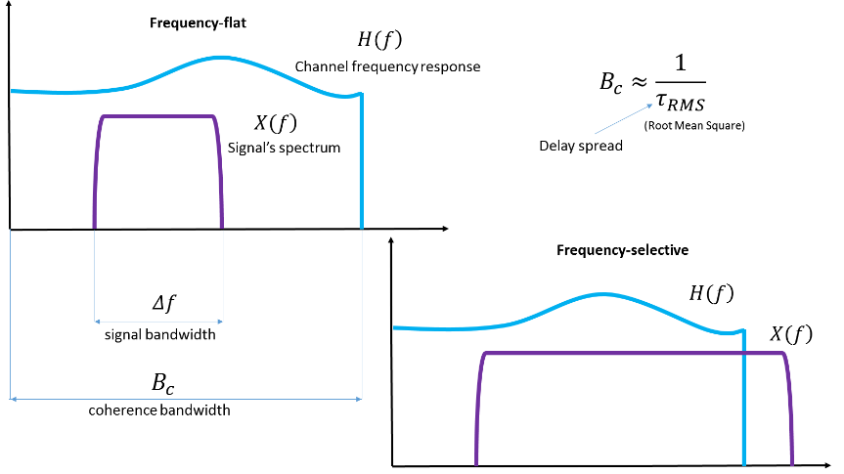

As the carrier frequency of a signal is varied, the magnitude of the change in amplitude will vary. The coherence bandwidth measures the separation in frequency after which two signals will experience uncorrelated fading.

In flat fading, the coherence bandwidth of the channel is larger than the bandwidth of the signal. Therefore, all frequency components of the signal will experience the same magnitude of fading.

In frequency-selective fading, the coherence bandwidth of the channel is smaller than the bandwidth of the signal. Different frequency components of the signal therefore experience uncorrelated fading.

The following figure summarizes the four different types of fading:

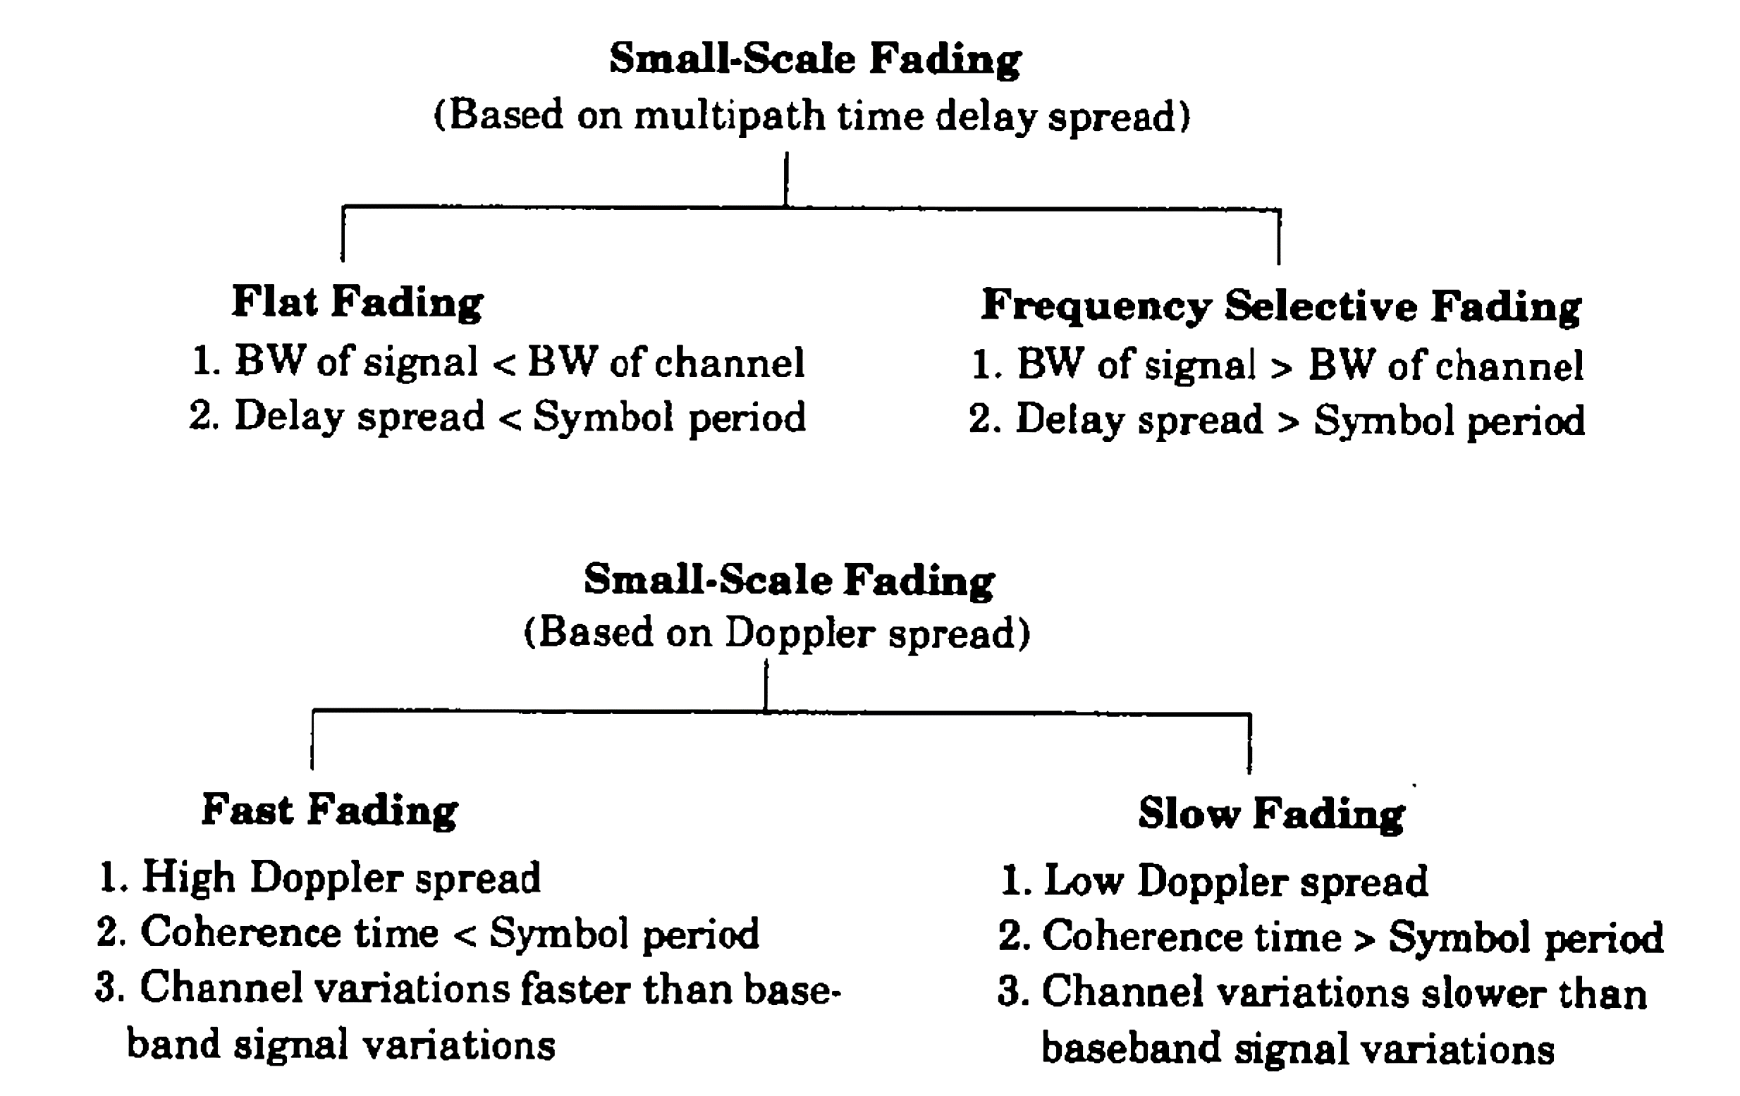

*Resources*

<https://en.wikipedia.org/wiki/Fading>

Rappaport Wireless Communications Principles And Practice 2Nd Edition, Prentice Hall, 2002 Theodore S. Rappaport, 978-0130422323

**Theoretical Questions**

1. Explain what coherence time and coherence bandwidth is.
2. Explain how multi-path propagation can cause frequency-selective fading.
3. In a typical urban area, the multipath delay spread of a wireless channel is . The bandwidth of the transmitted signal is . Is it a frequency-selective channel? Determine its coherence bandwidth.
4. Will a 50KHz signal experience flat or selective fading in the following channel?

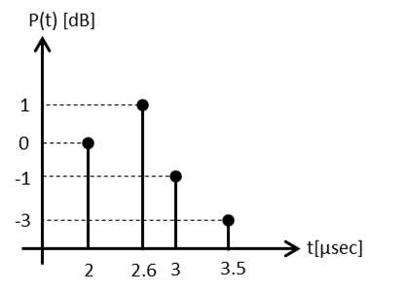

1. Calculate the mean excess delay, rms delay spread and maximum excess delay (10dB) for the multipath profile given in the figure below Estimate the 50% coherence bandwidth of the channel.

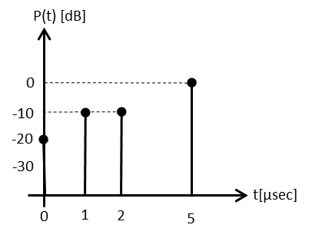

# Part 6 – Realistic Fading Simulation

In GNU Radio we can define a fixed Power Delay Profile (PDP) in terms of fractional sample times and powers using one of the channel models that GNU offers. Let’s also combine Frequency-selective time-varying fading for our signal.

* + Add a Signal Source of 1KHz Cosine with an amplitude of 1V.
  + Add a Fast Noise Source with an amplitude of 100mV.
  + Combine both using “Add” and connect to a “Frequency selective channel model” component with the following preferences:

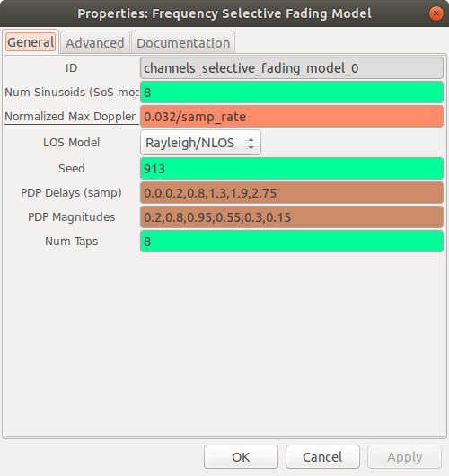

The Power Delay Profile values represent a more realistic model than so we can see more fading multi-path effects:

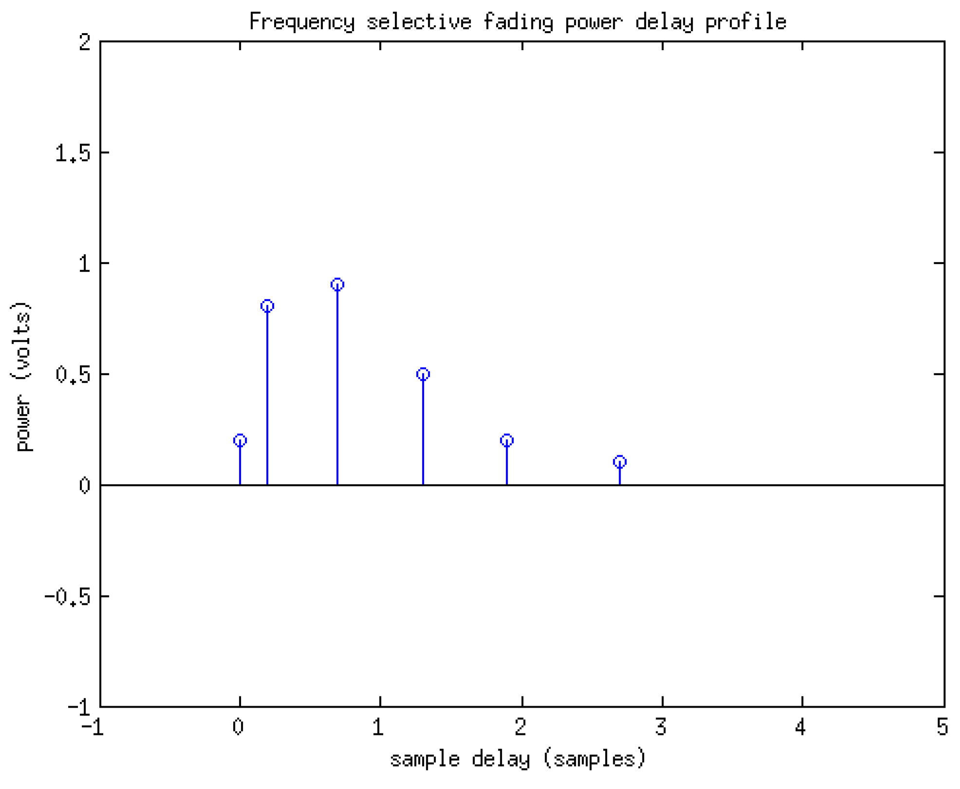

* Place a 2 inputs QT GUI Time Sink (with config panel) and connect to the signal before and after the channel model.
* Place a QT GUI Frequency Sink and connect to the signal after the channel model.
* Place a QT GUI Waterfall Sink and connect to the signal after the channel model.

If you preformed all the stages correctly, your system’s code should look like this:

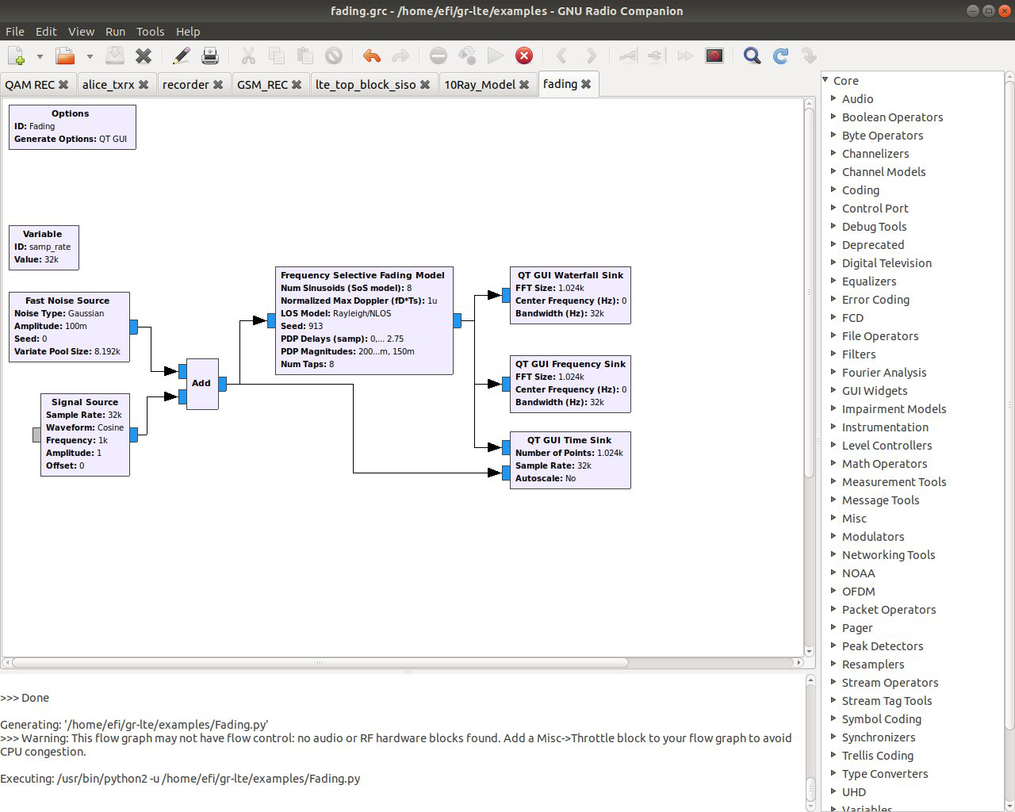

This are the signals that you should see in your GUI:

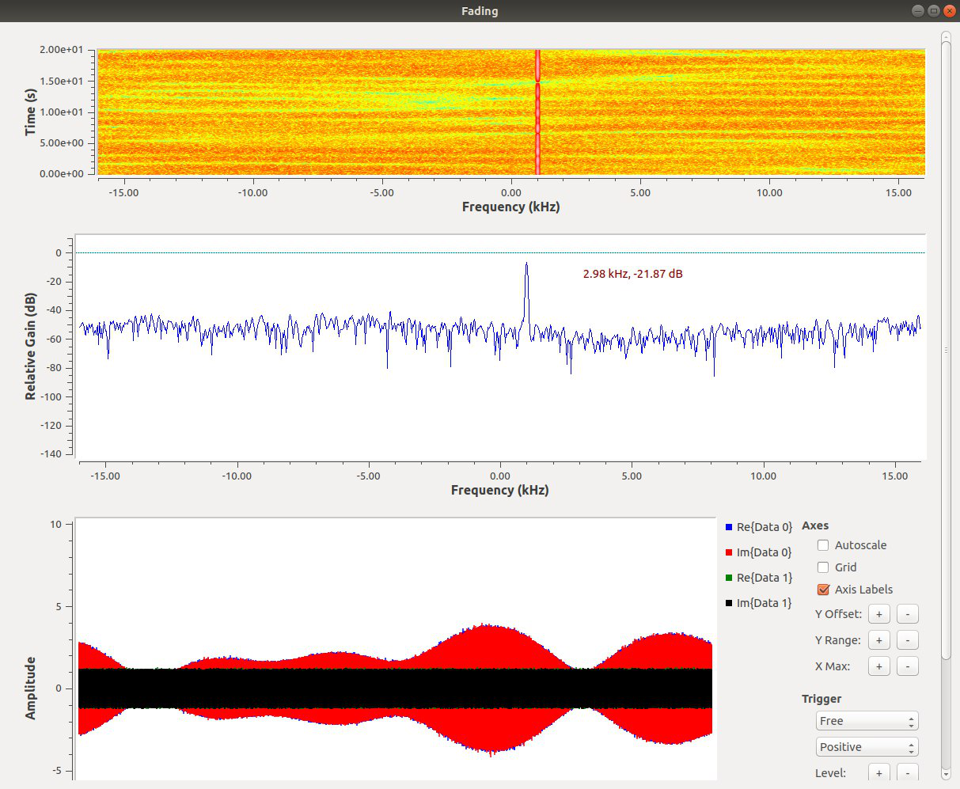

|  |
| --- |
| **Save your code and add it to your submission!** |

*Resources*

Wireless communications, Andrea Goldsmith, Stanford University, California, 2005, 9780511841224

<https://www.site.uottawa.ca/~sloyka/elg4179/Lec_5_ELG4179.pdf>

Rappaport Wireless Communications Principles And Practice 2Nd Edition, Prentice Hall, 2002 Theodore S. Rappaport, 978-0130422323